**ÔN TẬP KHỐI 1**

**REVIEW :UNIT 4**

1. **READING**
2. **Read and write tick ( √ ) or cross ( X )**

|  |  |  |  |
| --- | --- | --- | --- |
|  |  | This is a key. |  |
|  |  | This is a cat. |  |
|  |  | This is a lollipop. |  |
|  |  | It’s a jug. |  |
|  |  | It’s number ten. |  |
|  |  | It’s number nine. |  |

1. **Look at the picture and fill in the correct circle.**

|  |  |  |  |  |  |  |
| --- | --- | --- | --- | --- | --- | --- |
| 1. | 1. Sister 2. Mom 3. Grandma |  |  | 4. | 1. Sister 2. Brother 3. Dad |  |
| 2. | 1. Brother 2. Dad 3. Grandpa |  |  | 5. | 1. Grandma 2. Grandpa 3. Dad |  |
| 3. | 1. Grandma 2. Grandpa 3. Mom |  |  | 6. | 1. Mom 2. Dad 3. Sister |  |

1. **Look at the picture, choose the correct word and fill in the text.**

|  |
| --- |
| Grandma dad five sister mom brother grandpa |

Hi, my name is Billy. I am (1)………………years old.

This is my 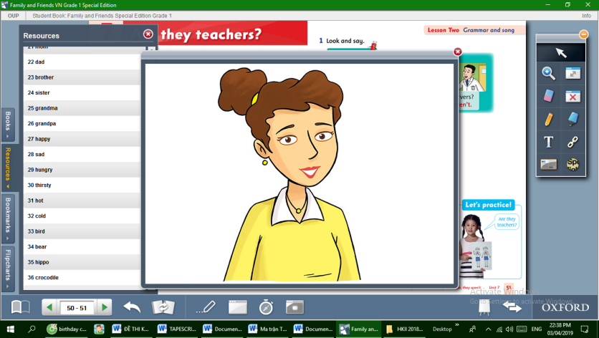 (2)…………………… ……….

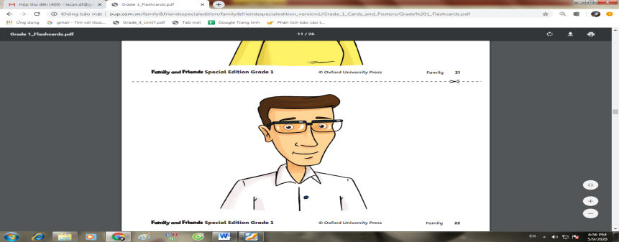

And this is my (3)…………………………

This is my 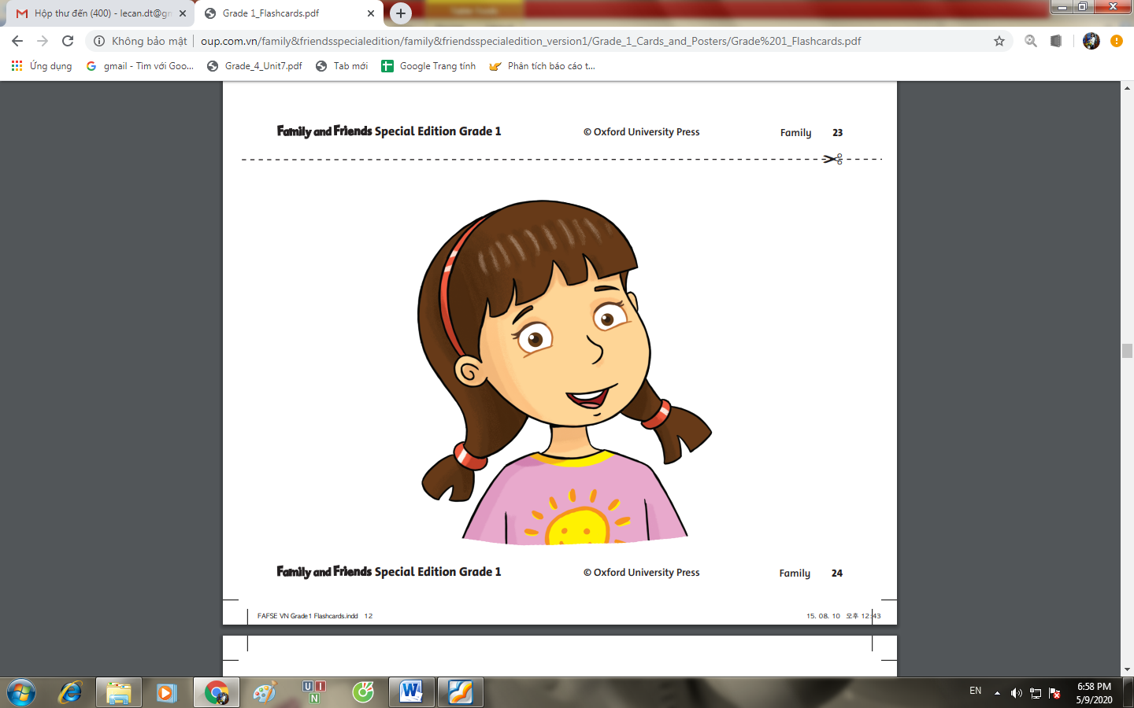(4)…………………………………..

This is my 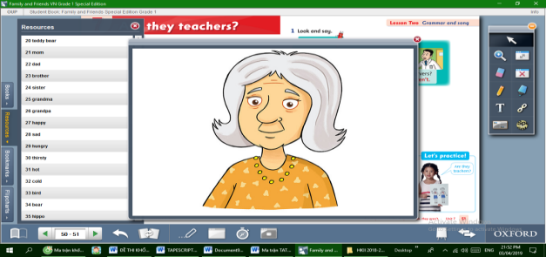(5)…………………………………….

This is my 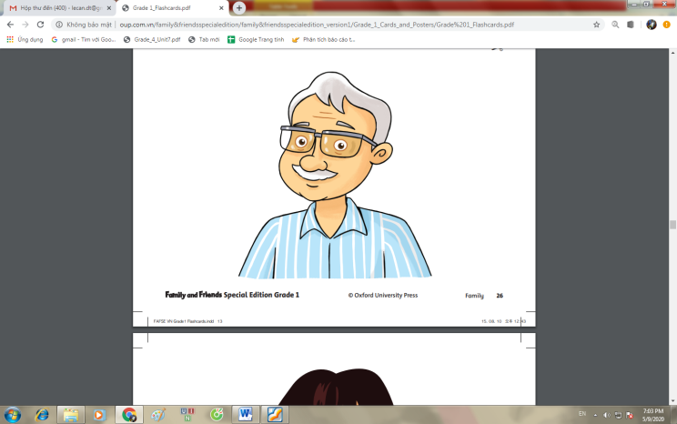(6)……………………………………..

I love my family so much!!

**B.WRITING**

**I. Look at the picture and write the word.**

|  |  |  |  |
| --- | --- | --- | --- |
|  |  | ___ ___ ___ ___ __ __ _ | M A N D R A G |
|  |  | ___ ___ ___ ___ ___ ___ | E R T S I S |
|  |  | ___ ___ ___ ___ ___ _ __ | E R T H R O B |
|  |  | ___ ___ ___ | A D D |

|  |  |  |  |
| --- | --- | --- | --- |
|  |  | ___ ___ ___ | O M M |

|  |  |  |  |
| --- | --- | --- | --- |
|  |  | __ _ __ _ _ __ __ | A P D R A N G |
|  | |  |  |  | | --- | --- | --- | |  |  |  | |  |  |
|  |  |  |  |
|  |  |  |  |

1. **Write the correct answers.**
2. What’s your name?

……………………………….

1. How old are you?

……………………………….

3.Who’s this? 

………………………………………..

4 What’s this?

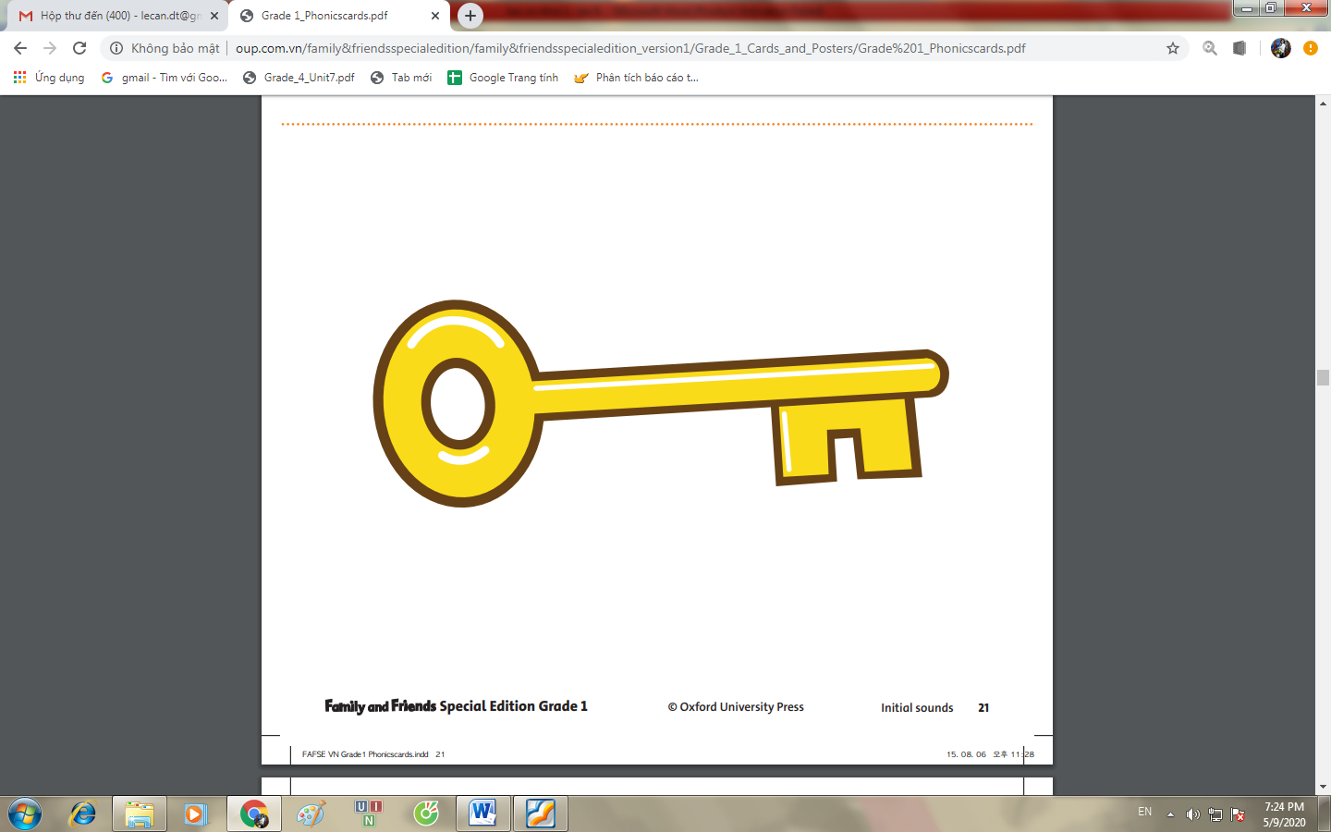

It’s a………………..

5.Is it a lion? 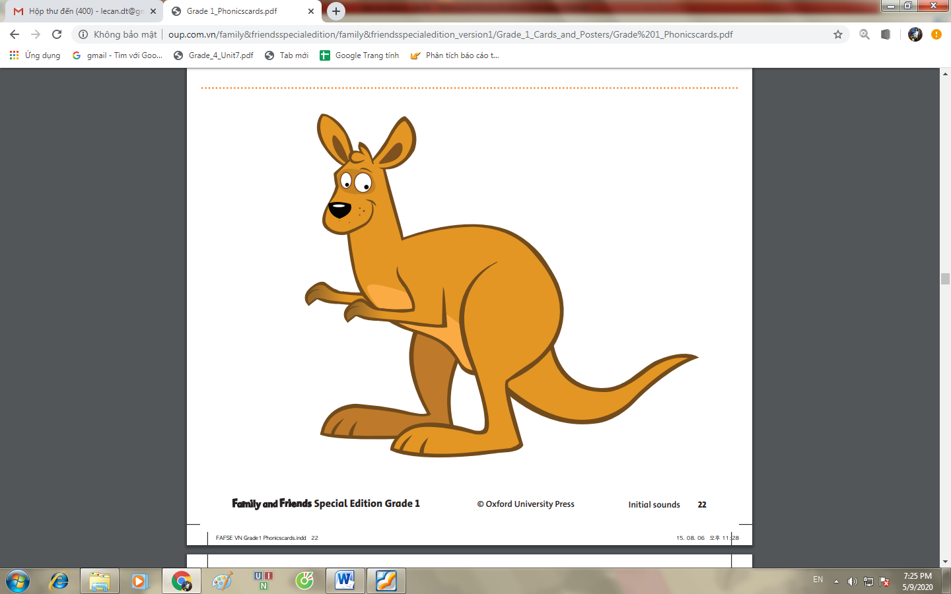

………………………………………………

5.How many people( người)? 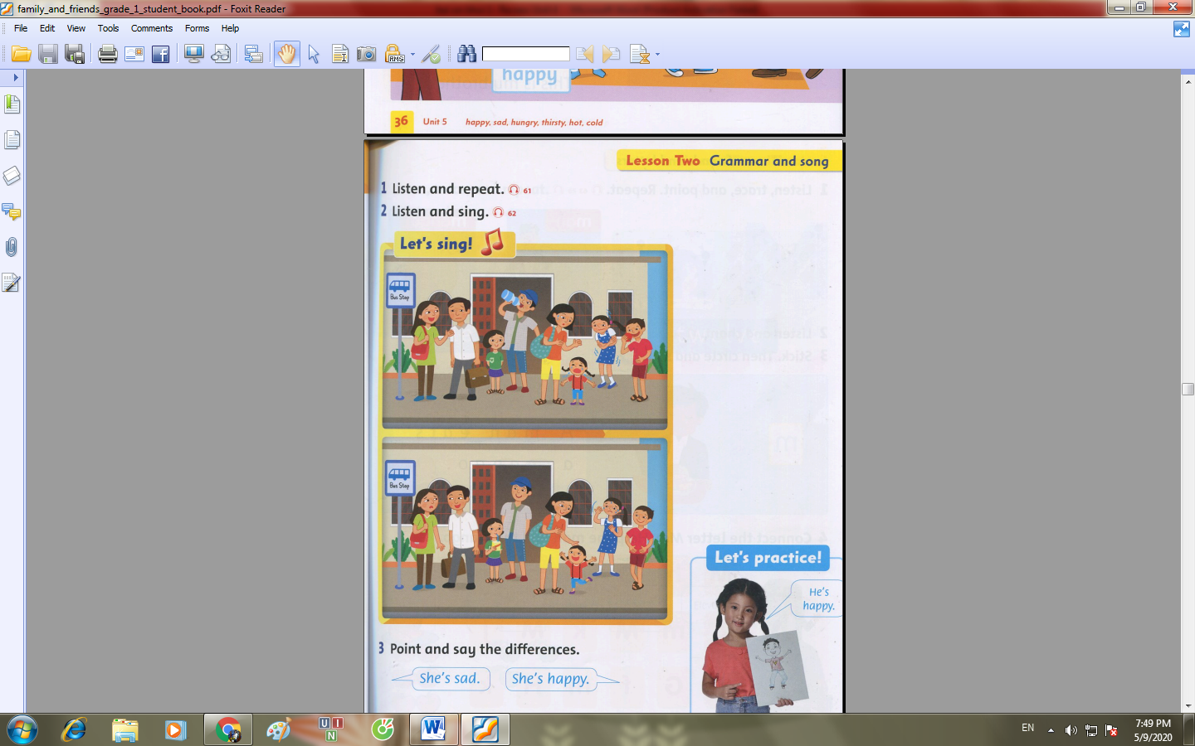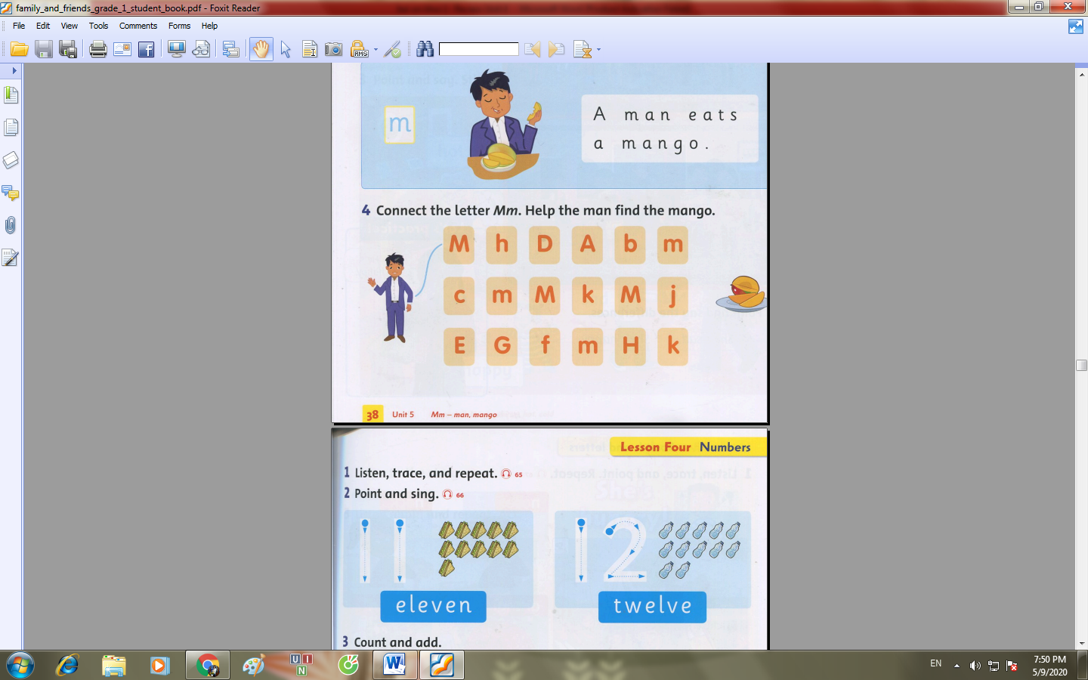

………………………………………………

**COPY WORDS**

1.mom mom mom mom mom mom

-

-

-

2. dad dad dad dad dad dad dad dad

-

-

-

3. brother brother brother brother

-

-

-

4. sister sister sister sister sister

-

-

-

5.**grandpa grandpa grandpa grandpa**

-

-

-

**6.grandma grandma grandma grandma grandma**

**-**

**-**

**-**

**7.key key key key key key key key key key key**

**-**

**-**

**-**

**8. lion lion lion lion lion lion lion lion lion**

**-**

**-**

**-**

**9. nine nine nine nine nine nine nine nine**

**-**

**-**

**-**

**10. ten ten ten ten ten ten ten ten ten ten**

**-**

**-**

**-**